Hands-on Projects

These projects should be completed in the order given. The hands-on projects presented in this chapter should take a total of three hours to complete. The requirements for this lab include:

* A computer with Fedora Linux installed according to Hands-on Project 2-1 and Ubuntu Server Linux installed according to Hands-On Project 6-1.

# Project 11-1

In this hands-on project, you use common compression utilities to compress and uncompress information on Fedora 20.

1. Boot your **Fedora** Linux virtual machine. Login to your chosen desktop environment as **user1** using password **LNXrocks!** and open up a terminal window.
2. At the terminal, become **root** by typing **su -** and press enter and provide **LNXrocks!** as the password.
3. At the command prompt, type **yum install ncompress** and press Enter. Press y when prompted to complete the installation of the ncompress RPM package (and any package dependencies).
4. At the command prompt, type **cp /etc/services .** and press Enter to make a copy of the /etc/services file in your home directory. Next, type **ll -h** at the command prompt and press Enter. Observe the file size of the services file.
5. At the command prompt, type **compress -v services** and press Enter to compress the services file. What was the compression ratio? **68.12%** Next, type **ll -h** at the command prompt and press Enter. Note the extension and file size of the services file.
6. At the command prompt, type **uncompress -v services.Z** and press Enter to decompress the services file.
7. At the command prompt, type **mkdir compress** and press Enter.
8. At the command prompt, type **cp /etc/hosts /etc/inittab compress/** and press Enter to copy the hosts and inittab file to your compress subdirectory. At the command prompt, type **compress -vr compress/** and press Enter to compress the contents of the compress subdirectory. Next, type **ll -R compress** at the command prompt and press Enter to view the contents of the compress directory.
9. At the command prompt, type **uncompress -vr compress** and press Enter to decompress the contents of the Desktop subdirectory. Next, type **ll -R compress** at the command prompt and press Enter to verify that these files were uncompressed.
10. At the command prompt, type **ps -ef | compress -v >psfile.Z** and press Enter to compress the output of the ps –ef command to a file called psfile.Z. Review the compression ratio. **65.58%**
11. At the command prompt, type **zless psfile.Z** and press Enter to view the compressed contents of the psfile.Z file. When finished, press q to quit the more utility.
12. At the command prompt, type **gzip -v services** and press Enter to compress the services file. What was the compression ratio? **79.7%** How does this ratio compare to the one obtained in Step 4? Why? **Because you can control the compression with the gzip.** Next, type **ll -h** at the command prompt and press Enter. What extension does the services file have and how large is it? **.gz and 133K**
13. At the command prompt, type **gunzip -v services.gz** and press Enter to decompress the services file.
14. At the command prompt, type **gzip -v -9 services** and press Enter to compress the services file. Review the compression ratio. **79.8%**
15. At the command prompt, type **gunzip -v services.gz** and press Enter to decompress the services file.
16. At the command prompt, type **gzip -v -1 services** and press Enter to compress the services file. Review the compression ratio. **76.6%**
17. At the command prompt, type **gunzip -v services.gz** and press Enter to decompress the services file.
18. At the command prompt, type **bzip2 -v services** and press Enter to compress the services file. Observe the compression ratio. Next, type **ll -h** at the command prompt and press Enter. Observe the file extension and file size.
19. At the command prompt, type **bunzip2 -v services.bz2** and press Enter to decompress the services file.
20. **Provide screenshot(s) of steps 3 through 18.**

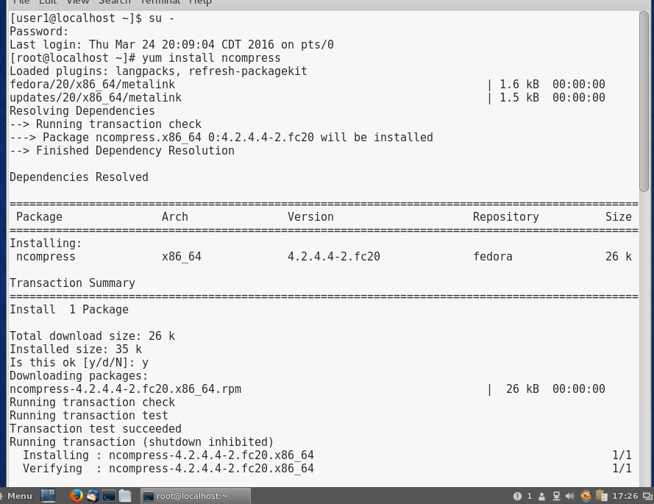

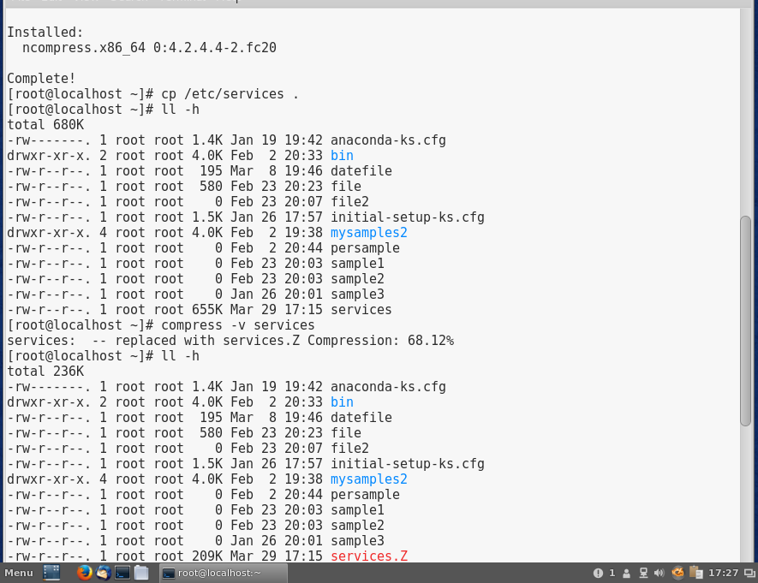

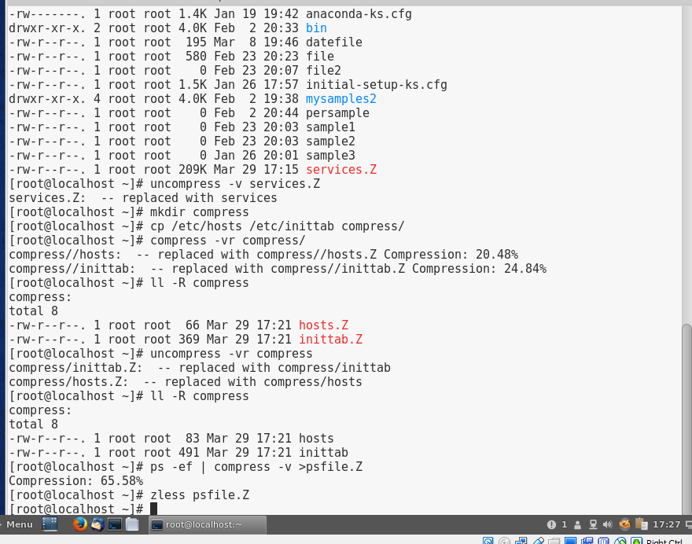

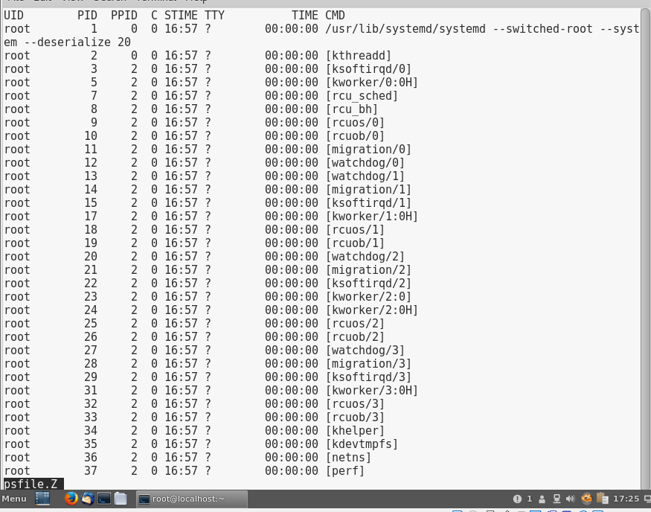

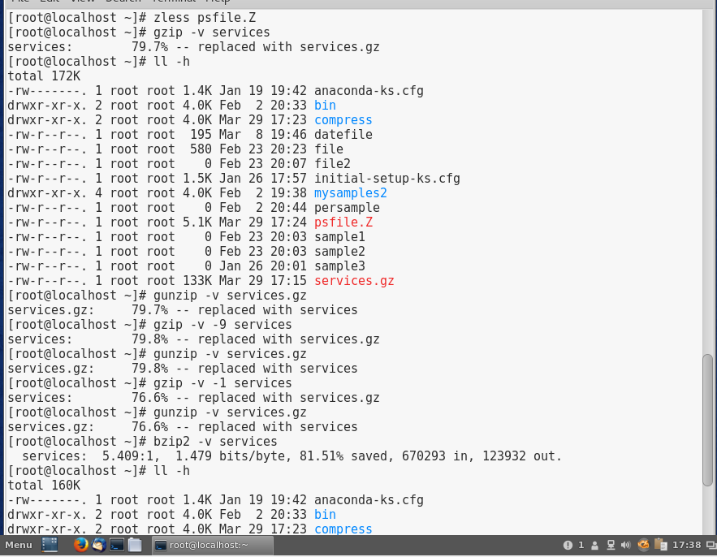

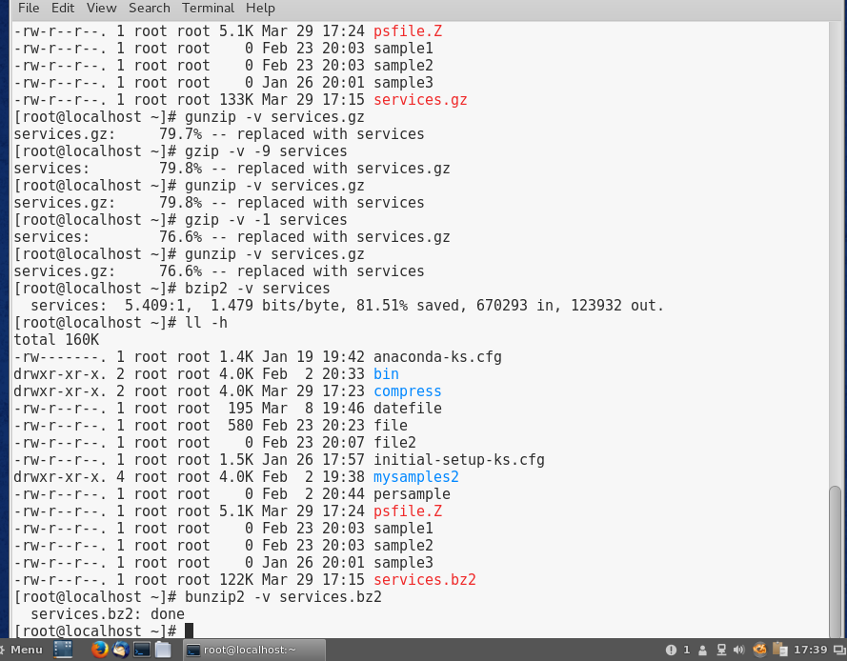

# Project 11-2

In this hands-on project, you create, view, and extract archives using the tar utility.

1. Boot your **Fedora** Linux virtual machine. Login to your chosen desktop environment as **user1** using password **LNXrocks!** and open up a terminal window.
2. At the terminal, become **root** by typing **su -** and press enter and provide **LNXrocks!** as the password.
3. At the command prompt, type **tar -cvf test1.tar /etc/samba** and press Enter to create an archive called test1.tar in the current directory that contains the /etc/samba directory and its contents. Next, type **ll** at the command prompt and press Enter.
4. At the command prompt, type **tar -tvf test1.tar** and press Enter. Review the contents of the test1.tar archive.
5. At the command prompt, type **mkdir /new1** and press Enter. Next, type **cd /new1** at the command prompt and press Enter to change the current directory to the /new1 directory.
6. At the command prompt, type **tar -xvf /root/test1.tar** and press Enter to extract the contents of the test1.tar archive. Next, type **ls -RF** at the command prompt and press Enter to view the contents of the /new1 directory.
7. At the command prompt, type **cd** and press Enter to return to your home directory.
8. At the command prompt, type **tar -zcvf test2.tar.gz /etc/samba** and press Enter to create a gzip-compressed archive called test2.tar.gz in the current directory that contains the /etc/samba directory and its contents. Next, type **ll -h** at the command prompt and press Enter. Compare the file size from the output in step 3.
9. At the command prompt, type **tar -ztvf test2.tar.gz** and press Enter. Review the output.
10. At the command prompt, type **mkdir /new2** and press Enter. Next, type **cd /new2** at the command prompt and press Enter to change the current directory to the /new2 directory.
11. At the command prompt, type **tar -zxvf /root/test2.tar.gz** and press Enter to uncompress and extract the contents of the test2.tar.gz archive. Next, type **ls -RF** at the command prompt and press Enter to view the contents of the /new2 directory.
12. At the command prompt, type **cd** and press Enter to return to your home directory.
13. At the command prompt, type **rm -Rf /new[12]** and press Enter to remove the directories created in this hands-on project.
14. At the command prompt, type **rm -f /root/test\*** and press Enter to remove the tar archives created in this hands-on project.
15. **Provide screenshot(s) of steps 3 through 14.**

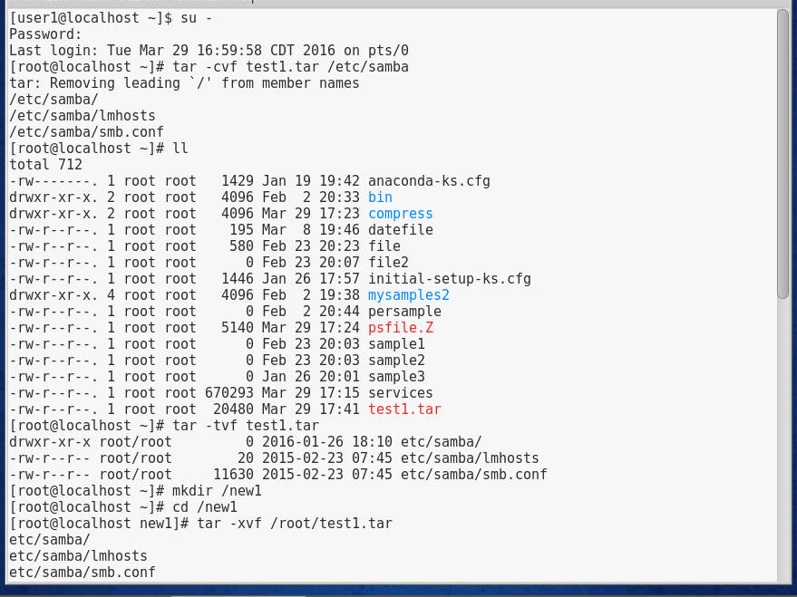

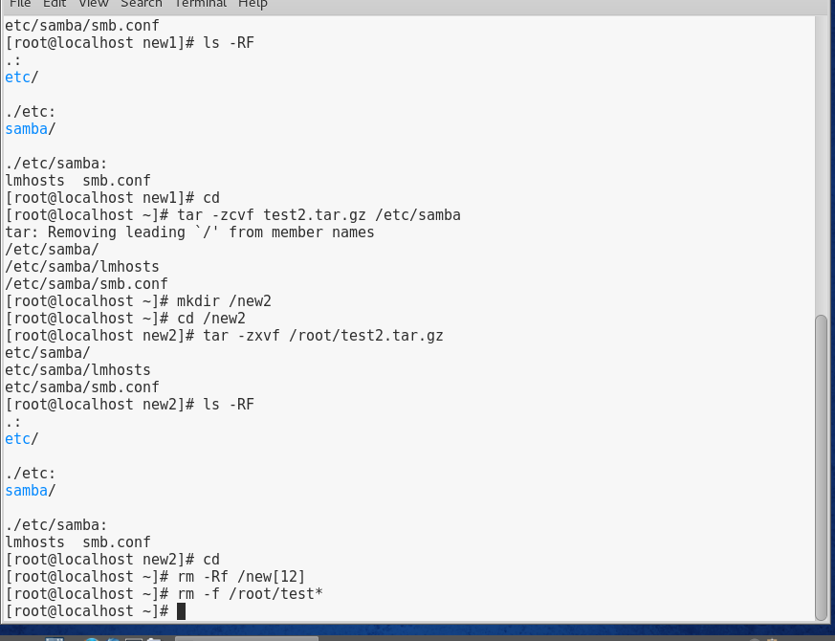

# Project 11-3

In this hands-on project, you create, view, and extract archives using the cpio and dump utilities.

1. Boot your **Fedora** Linux virtual machine. Login to your chosen desktop environment as **user1** using password **LNXrocks!** and open up a terminal window.
2. At the terminal, become **root** by typing **su -** and press enter and provide **LNXrocks!** as the password.
3. At the command prompt, type **find /etc/samba | cpio -ovcBL -O test.cpio** and press Enter to create an archive in the file test.cpio that contains the /etc/samba directory and its contents. What does each option indicate in the aforementioned command? **It’s finding the /etc/samba directory and then copies the files. The –O represents the output archive.**
4. At the command prompt, type **cpio -ivtB -I test.cpio** and press Enter. What is displayed? What does each option indicate in the aforementioned command? **It displays the user privaleges, the owners, and the copied files. The –I represents the input archive.**
5. At the command prompt, type **cpio -ivcdumB -I test.cpio** and press Enter to extract the contents of the archive in the test.cpio file. To what location were the files extracted? Were any files overwritten? What does each option indicate in the aforementioned command? **The files were extracted to /etc/samba. No files were overwritten. The cpio stand for copying the files, and the –I represents the input archive for the file.**
6. At the command prompt, type **yum install dump** and press Enter. Press y when prompted to complete the installation of the dump RPM package (and any package dependencies).
7. At the command prompt, type **dump -0uf test.dump /dev/sda1** and press Enter to create an archive of the /boot filesystem in the archive file test.dump. What type of backup was performed? Will the /etc/dumpdates file be updated?
8. At the command prompt, type **cat /etc/dumpdates** and press Enter. Does the file indicate your full backup and time? **Yes.**
9. At the command prompt, type **mkdir /new** and press Enter. Next, type **cd /new** at the command prompt and press Enter to change the current directory to the /new directory.
10. At the command prompt, type **restore -rf /root/test.dump** and press Enter. What was displayed? Are absolute or relative pathnames used? **Nothing was displayed, and there are no pathnames used or posted.**
11. Type **ls -F** at the command prompt and press Enter to view the contents of the /new directory. What is displayed? **See screenshot.**
12. At the command prompt, type **cd** and press Enter to return to your home directory.
13. At the command prompt, type **rm -Rf /new** and press Enter to remove the directory created in this hands-on project.
14. At the command prompt, type **rm -f /root/test\*** and press Enter to remove the archives created in this hands-on project.
15. **Provide screenshot(s) of steps 3 through 14.**

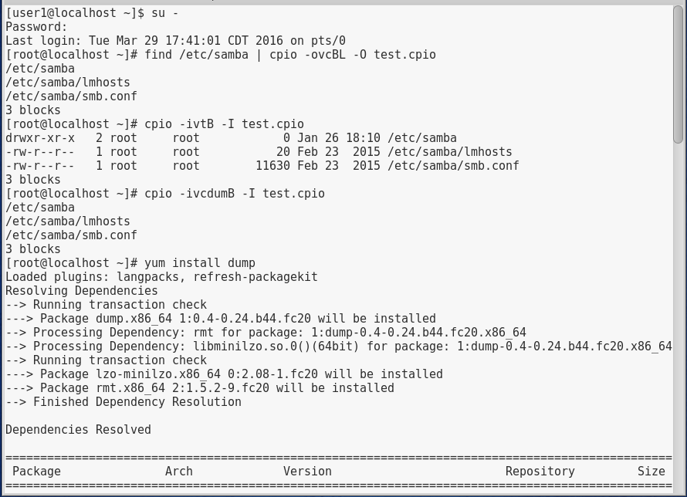

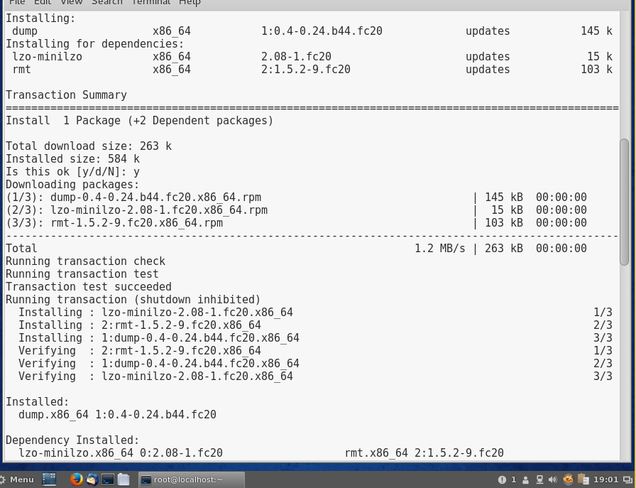

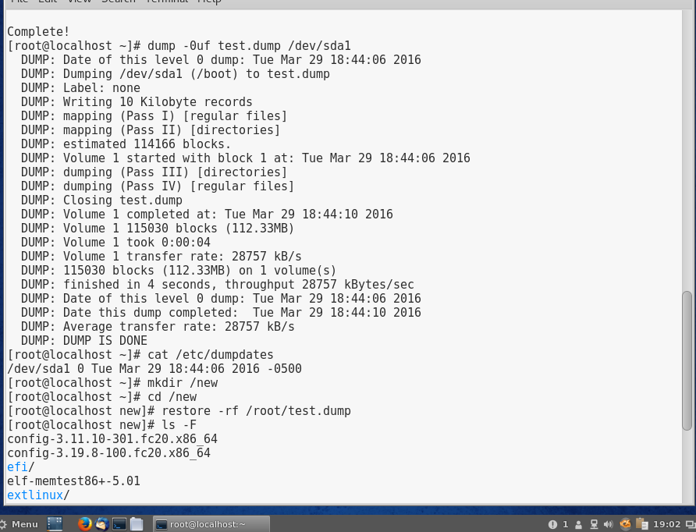

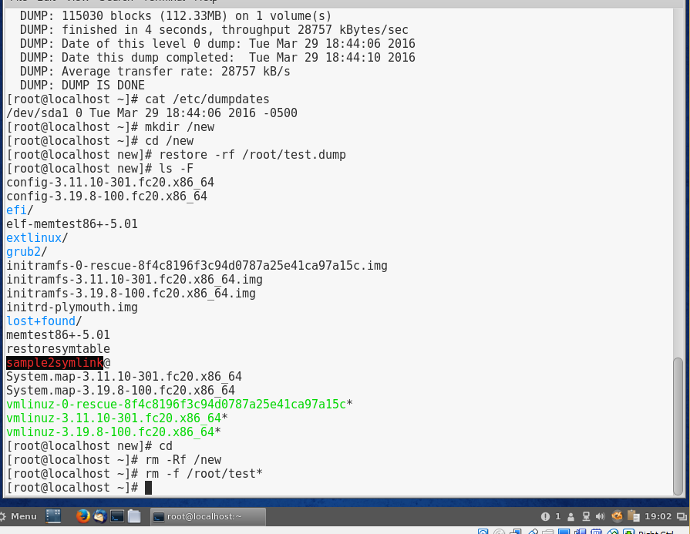

# Project 11-4

In this hands-on project, you compile and install a program from source code.

1. Boot your **Fedora** Linux virtual machine. Login to your chosen desktop environment as **user1** using password **LNXrocks!** and open up a terminal window.
2. At the terminal, become **root** by typing **su -** and press enter and provide **LNXrocks!** as the password.
3. At the command prompt, type **wget https://github.com/rdesktop/rdesktop/releases/download/v1.8.3/rdesktop-1.8.3.tar.gz** and press Enter to download the source code for rdesktop.
4. At the command prompt, type **yum groupinstall "Development Tools"** and press Enter to install the compiler tools from a software repository.
5. At the command prompt, type **yum install libX11-devel openssl-devel** and press Enter to install the X11 and OpenSSL development libraries from a software repository.
6. At the command prompt, type **tar -zxvf rdesktop-1.8.3.tar.gz** and press Enter to uncompress and extract the contents of the tarball. Next, type ls -F at the command prompt and press Enter. What directory was created? **The rdesktop directory was created.**
7. At the command prompt, type **cd rdesktop-1.8.3** and press Enter. Next, type **ls -F** at the command prompt and press Enter. Is there an executable configure program? Are there README and INSTALL files present? **Yes to both questions.**
8. At the command prompt, type **./configure --disable-credssp --disable-smartcard** and press Enter to run the configure script without configuring for credssp and smartcard support. What does this program do? Near the bottom of the output, can you see whether the Makefile was created successfully? **This program checked all the files, and there was a Makefile that was created.**
9. At the command prompt, type **make** and press Enter. What does the make program do? Which program compiles the different parts of the program? **The make command looks for Makefile, and uses it to compile source code into binary using the compiler.**
10. At the command prompt, type **make install** and press Enter. What does the make install command do?  **It copies compiled executable programs to the correct location.**
11. At the command prompt, type **cd** and press Enter to return to your home directory. Next, type **rm -Rf rdesktop-1.8.3** to remove the source code directory for rdesktop.
12. At the command prompt, type **which rdesktop** and press Enter. Which directory contains the rdesktop executable program? Is a central database updated with this information? **/usr/local/bin**
13. At the command prompt, type **man rdesktop** and press Enter. View the available options for the rdesktop command and press q to quit when finished.
14. **Provide screenshot(s) of steps 3 through 13.**

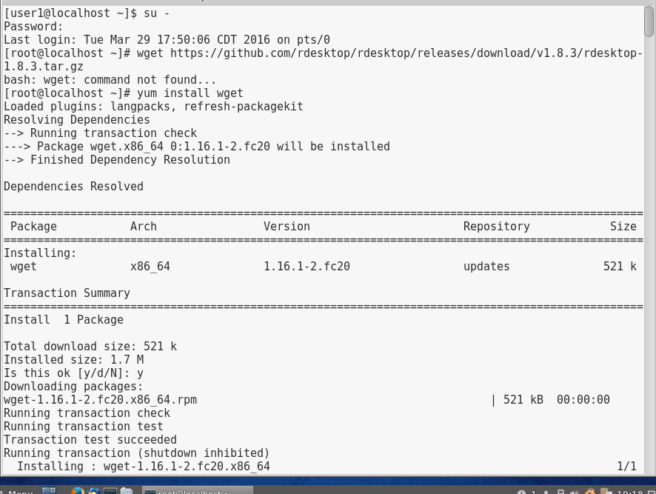

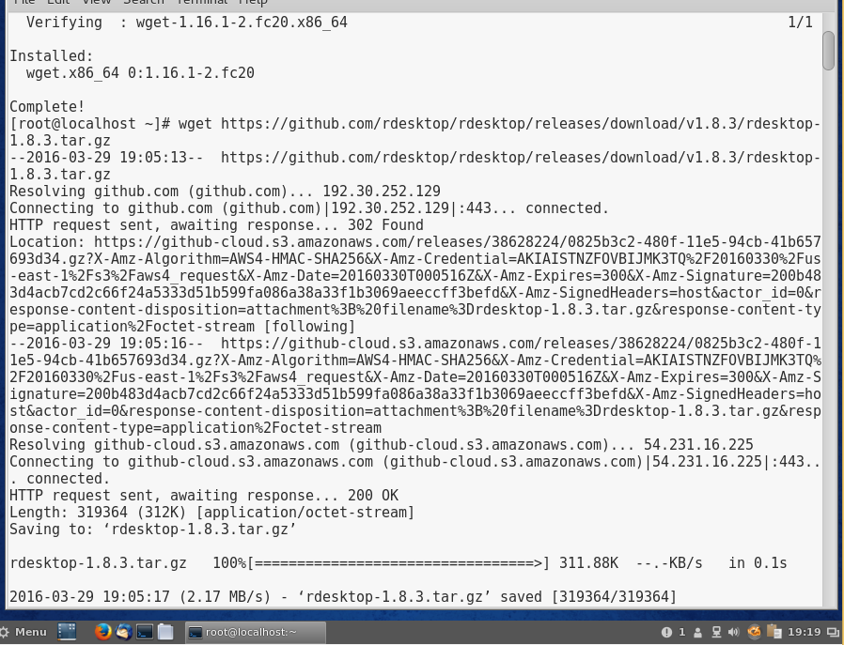

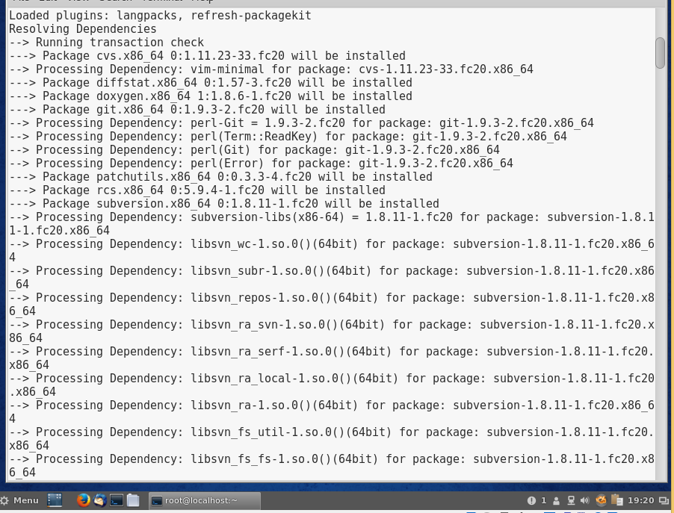

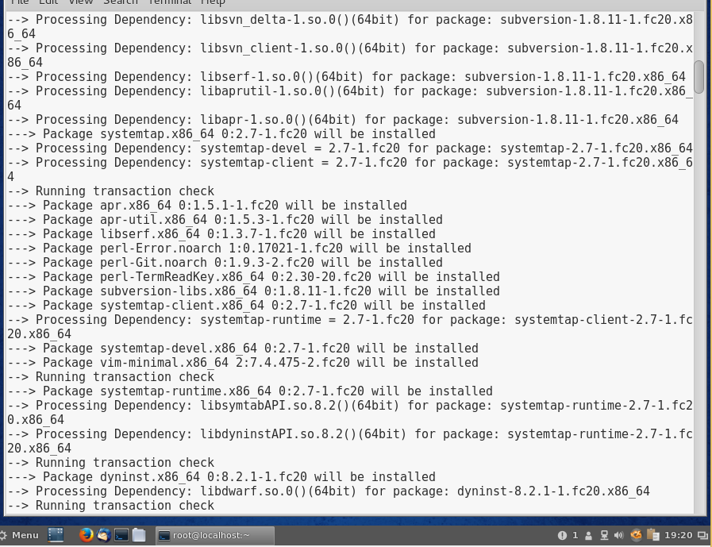

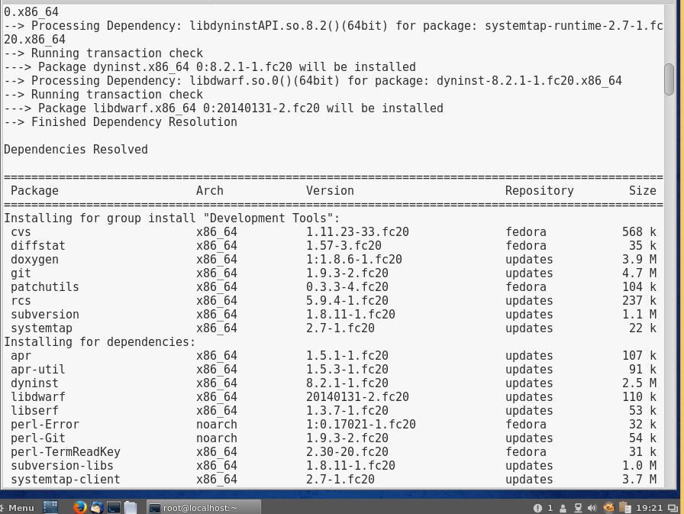

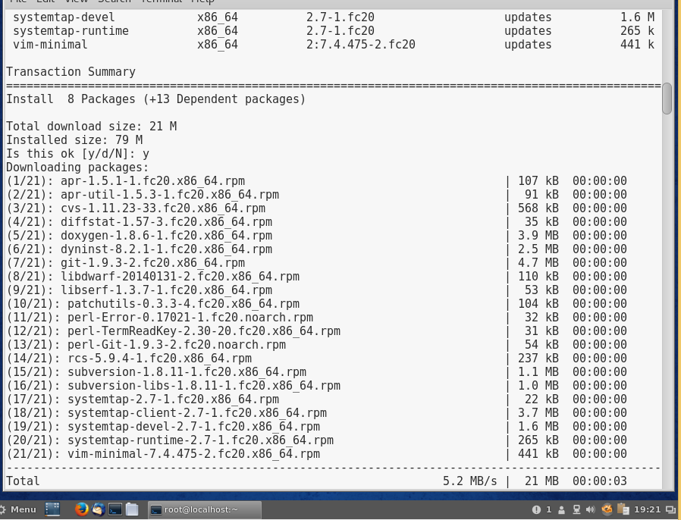

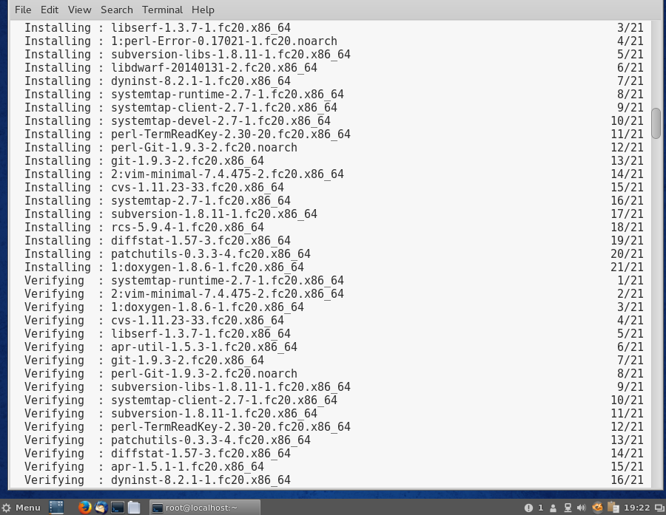

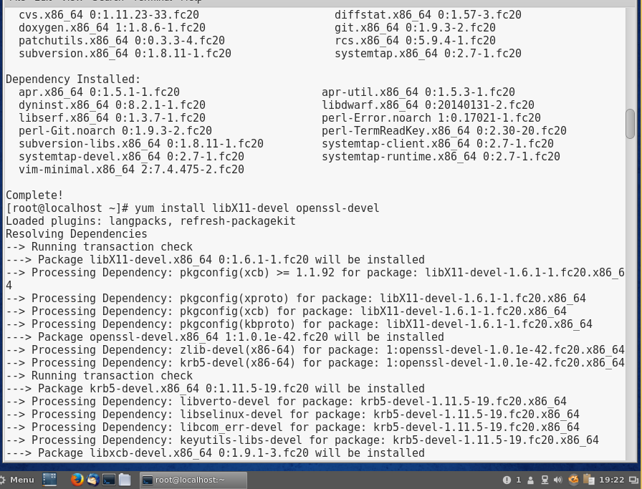

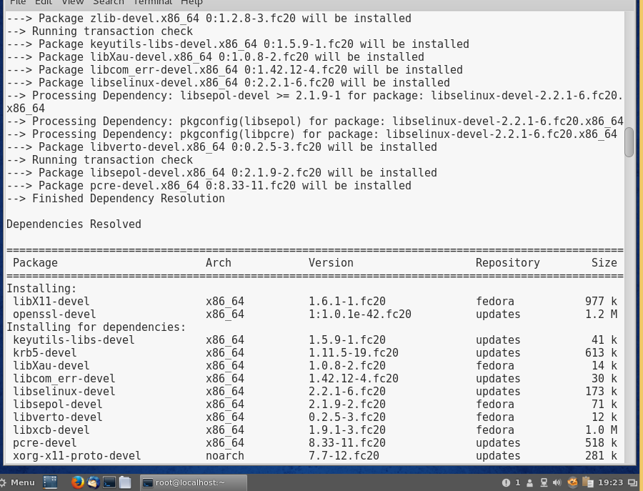

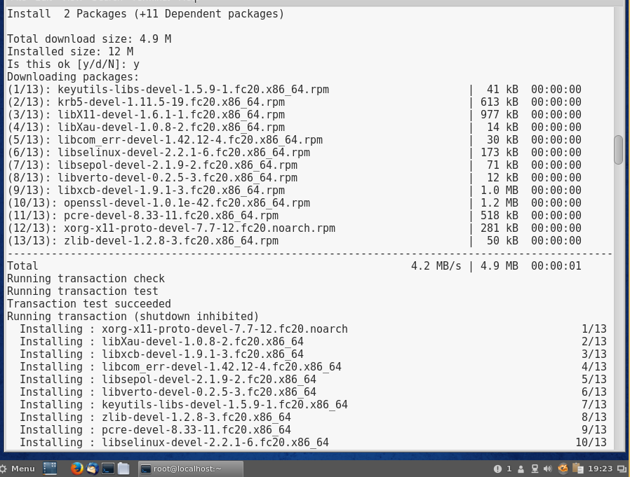

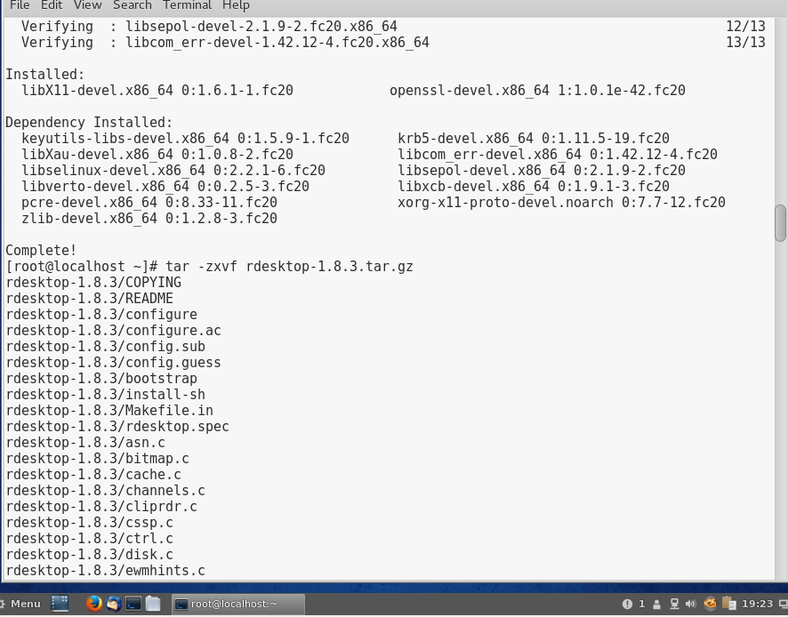

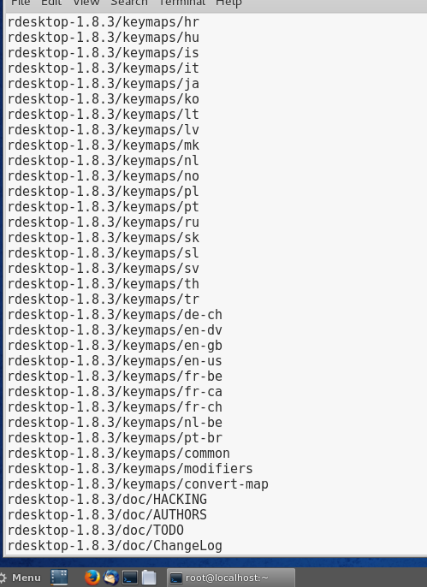

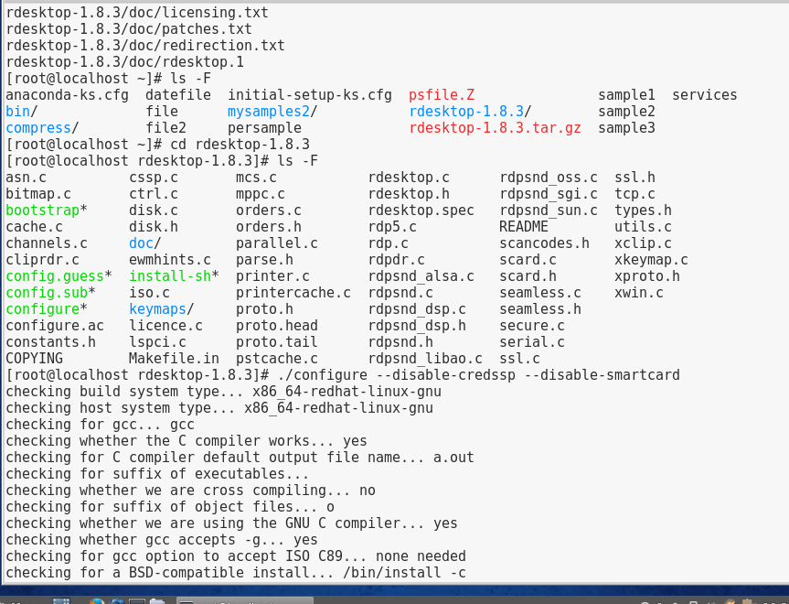

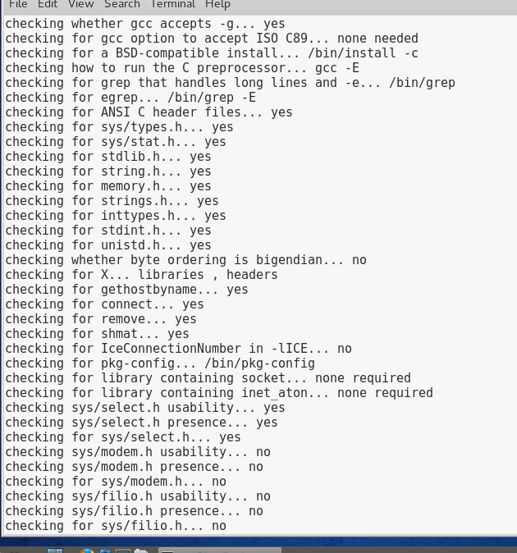

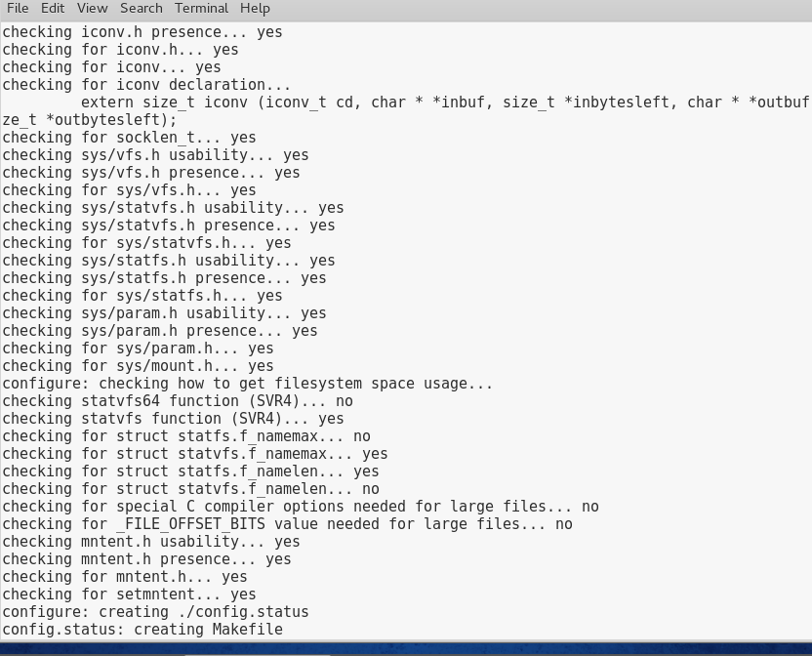

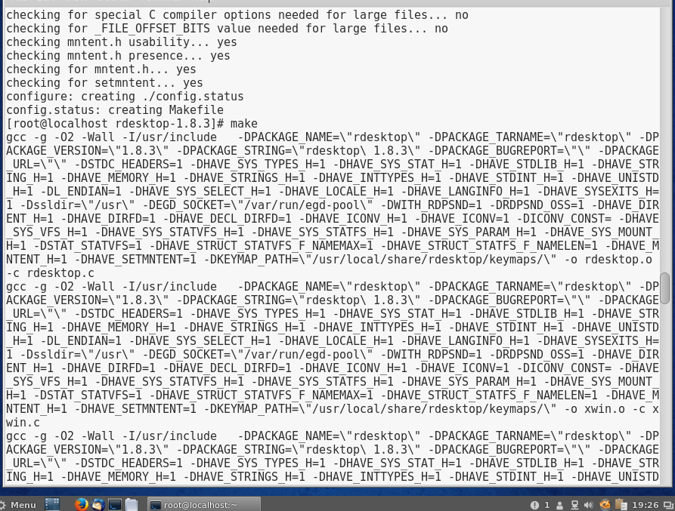

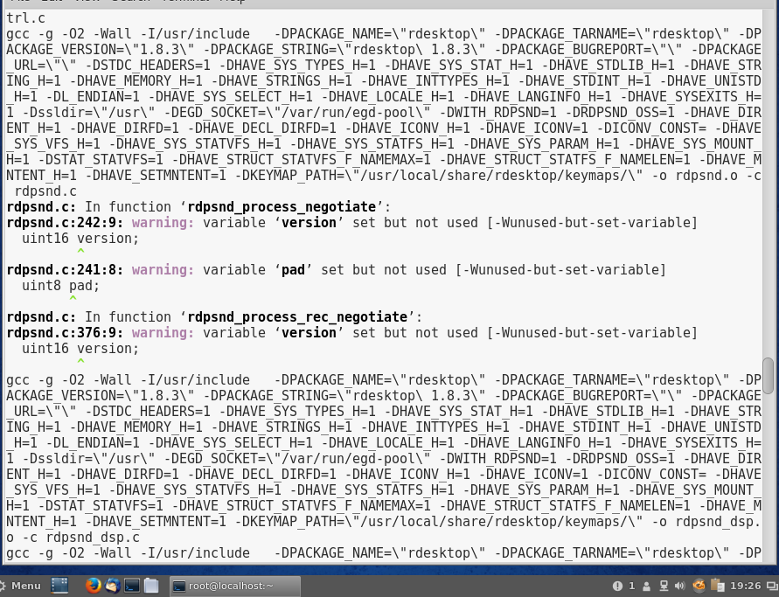

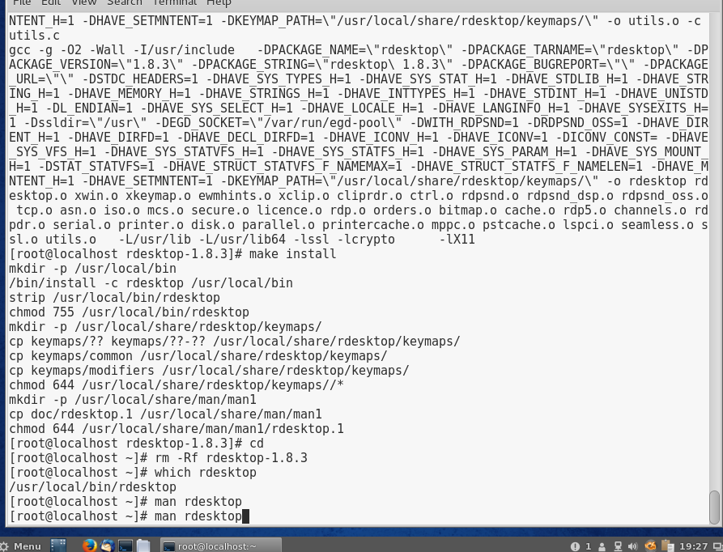

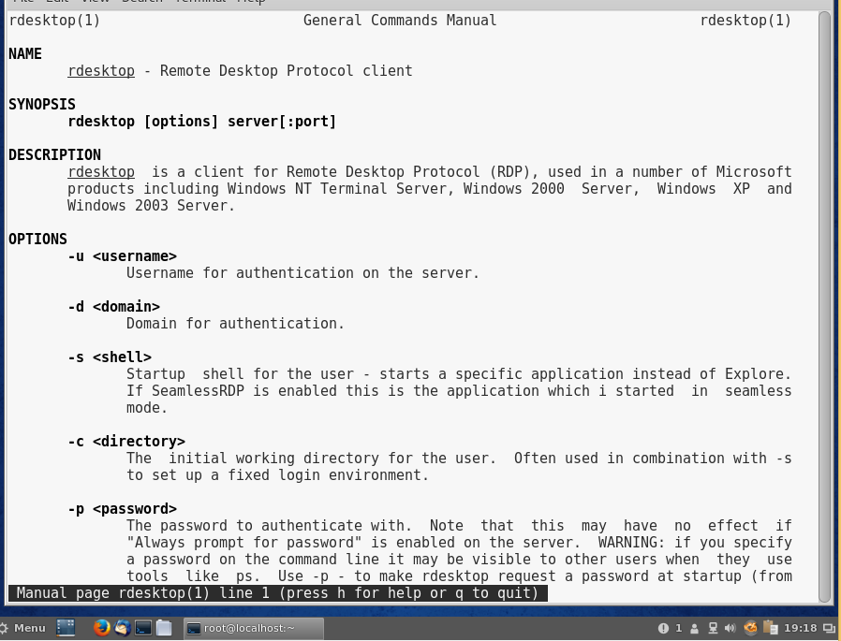

# Project 11-5

In this hands-on project, you use the rpm and yum commands to query, remove, and install the ncompress RPM package.

1. Boot your **Fedora** Linux virtual machine. Login to your chosen desktop environment as **user1** using password **LNXrocks!** and open up a terminal window.
2. At the terminal, become **root** by typing **su -** and press enter and provide **LNXrocks!** as the password.
3. At the command prompt, type **rpm -qa | less** and press Enter to view the RPM packages installed on your computer. Are there many of them? **Yes.** Briefly scroll through the list and press q when finished to exit the less utility.
4. At the command prompt, type **rpm -q ncompress** and press Enter. Is the ncompress RPM package installed on your computer? When did you install it? **Yes**
5. At the command prompt, type **rpm -qi ncompress** and press Enter to view the information about the ncompress RPM package. What license does this package use? **Public Domain, and it was installed March 29, 2016.**
6. At the command prompt, type **rpm -ql ncompress** and press Enter to view the locations of all files that belong to the ncompress package. What directory holds the compress and uncompress executables? **/usr/share/man/man1**
7. At the command prompt, type **rpm -e ncompress** and press Enter. What does this option to the rpm command do? **It is used to remove a package from the system.**
8. At the command prompt, type **rpm -q ncompress** and press Enter. Is the ncompress RPM package installed? **No it is not.**
9. At the command prompt, type **yum search compress | less** and press Enter. Is the ncompress RPM package listed? **Yes.** Press q to quit the less utility.
10. At the command prompt, type **yum list available | grep compress** and press Enter. Is the ncompress RPM package available for installation from a software repository? **Yes**
11. At the command prompt, type **yum install ncompress** and press Enter. Press y when prompted to complete the installation.
12. At the command prompt, type **rpm -q ncompress** and press Enter. Is the ncompress RPM package installed? **Yes it is.**
13. **Provide screenshot(s) of steps 3 through 12.**

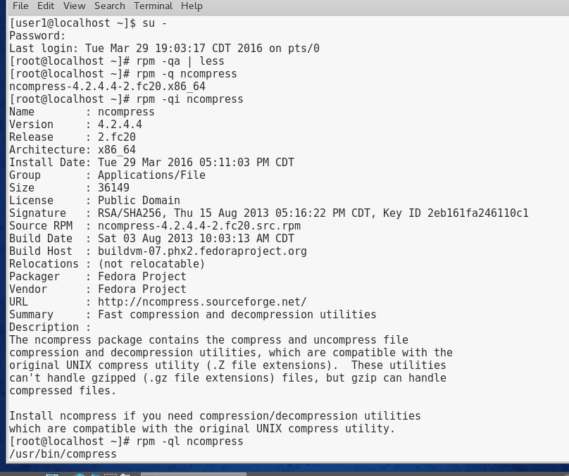

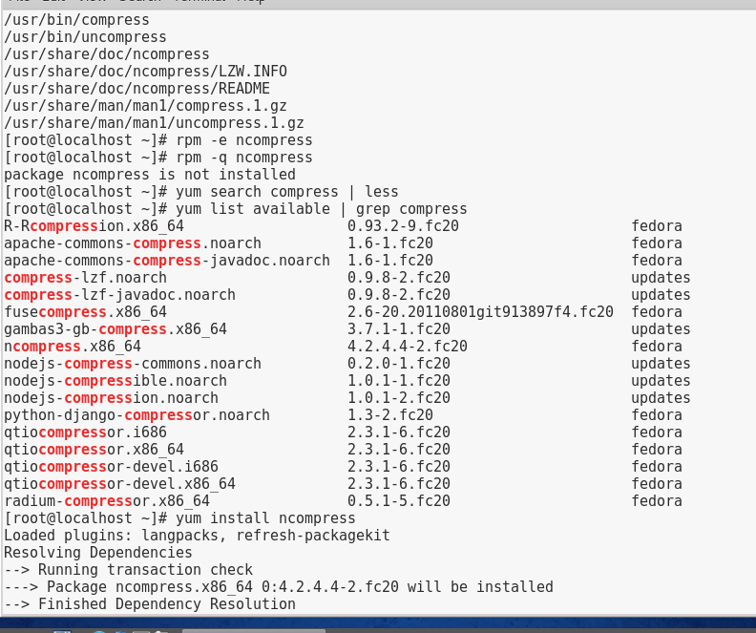

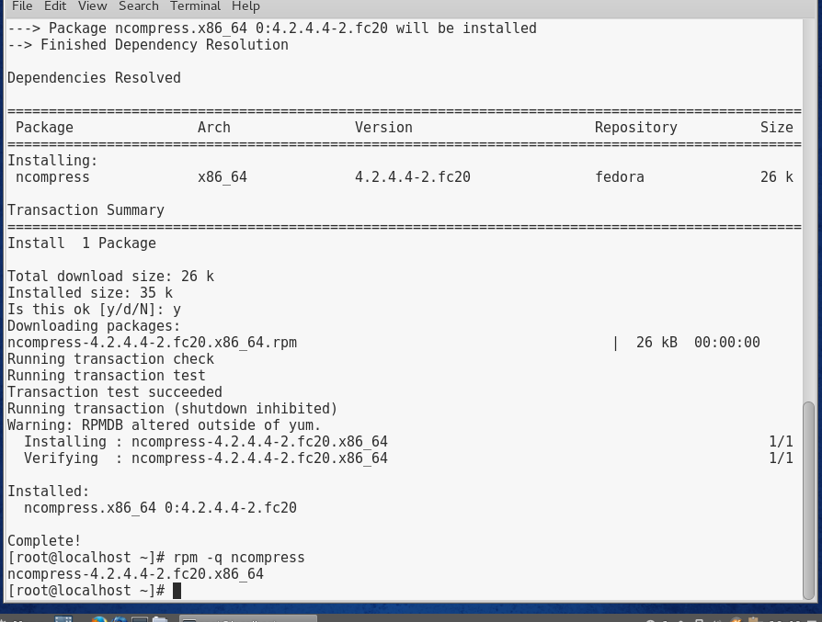

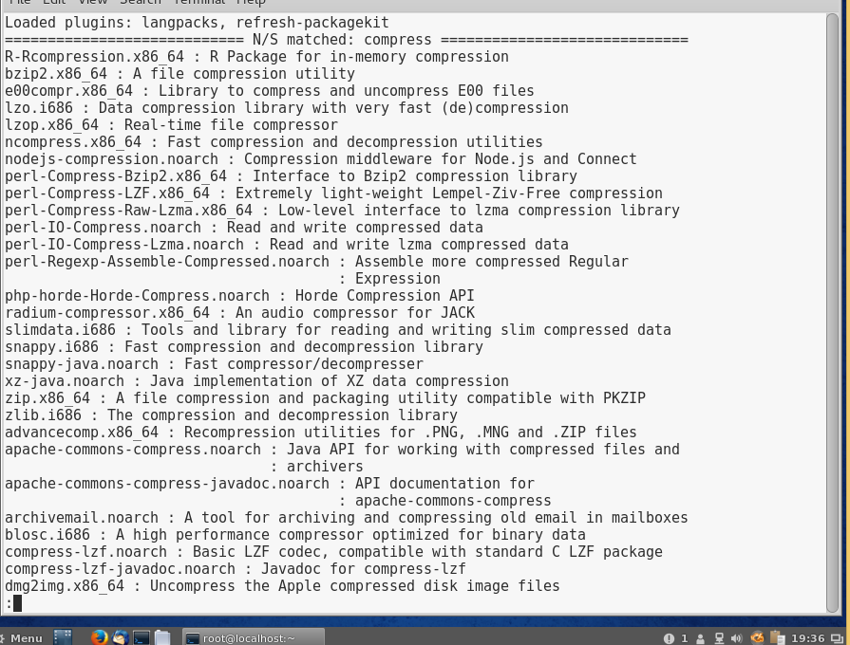

# Project 11-6

In this hands-on project, you lock and unlock user accounts on Fedora Linux using command-line utilities.

1. Boot your **Ubuntu** Linux virtual machine. Login to your chosen desktop environment as **user1** using password **LNXrocks!** and open up a terminal window.
2. At the command prompt, type **dpkg -l | less** and press Enter to view the DPM packages installed on your computer. Briefly scroll through the list and press q when finished to exit the less utility.
3. At the command prompt, type **dpkg -L ncompress** and press Enter to list the files that comprise the ncompress package, is the ncompress DPM package installed on your computer? **No**
4. At the command prompt, type **apt-cache search compress | less** and press Enter. Is ncompress listed? **Yes.** Press q to quit the less utility when finished.
5. At the command prompt, type **apt-get install ncompress** and press Enter to install the ncompress DPM package from a software repository.
6. At the command prompt, type **dpkg -L ncompress** and press Enter to list the files that comprise the ncompress package. Next, type **dpkg -p ncompress** at the command prompt and press Enter to view the detailed information about the ncompress package.
7. At the command prompt, type **apt-get purge ncompress** and press Enter. Press y when prompted. What does the purge option do? **The purge option allows you to open the lock file.**
8. At the command prompt, type **aptitude install ncompress** and press Enter. What does this command do? **It reads, prepares, unpacks, processes, and sets up the file.**
9. **Provide screenshot(s) of steps 3 through 8.**

